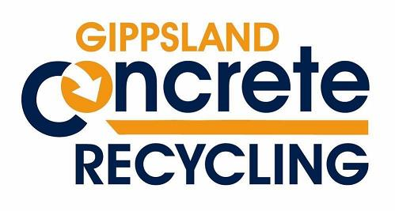

GCR Asbestos Policy

Gippsland Concrete Recycling does not in any circumstance accept the disposal of asbestos at the recycling facility.

GCR is not authorized to accept the disposal of asbestos. In case that there is asbestos found in a load of material disposed by a person or company, GCR will contact an authorized company to remove the asbestos off site and will contact the person or company responsible and send the invoice for the removal to the responsible party.

