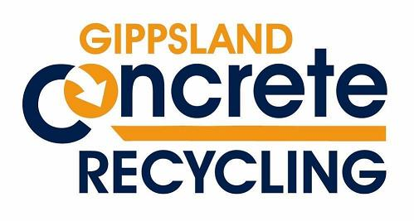
GCR is temporarily offering disposal of concrete at no charge. Conditions apply.

GCR Free Concrete disposal policy

- All material that will be accepted for free disposal must meet the following criteria:
- No excess dirt, clay or mud
- No rubbish plastic, timber, tree roots or wood
- No tiles or Lino
- No cement sheet, plaster board or asbestos
- No mixed loads with bricks or asphalt
- Oversize concrete Footings will incur a charge at the usual rate (bigger than 800mm).

- All loads need to be inspected by a GCR staff member and approved for free disposal.
If the load does meet all the requirements and is approved by a GCR staff member you will be allowed to tip at no charge, we will still write a docket to record that the disposal is done ethically at your job.
If the load does not meet these specific requirements but is deemed eligible to be disposed of at our facility by our usual standards these will be able to be disposed of on-site but charges will apply at normal rates.

